**This is why Handcrafted Shirts are a better choice:**

No matter who we are, which religion do we follow or which gender we belong to, Everyone is obsessed with a smart, appealing and highly comfortable outfit. When it comes to our charming Men’s, the first and most essential element which takes their personality games to the next level of charm is a Designer Shirt. Yes! Shirts are the first most thing which is noticed by your surroundings and if I am not wrong, there’s nobody out there who don’t want to get noticed. When we talk about apparels, we all know that handcrafted products are far better than machine-crafted one. We as Indians are blessed with a born-talent of Stitching and designing and we at Abkasa took the responsibility to showcase the extraordinary perks of Handcrafted products by introducing a wide range of finely handcrafted shirts to enhance your overall look and charm.

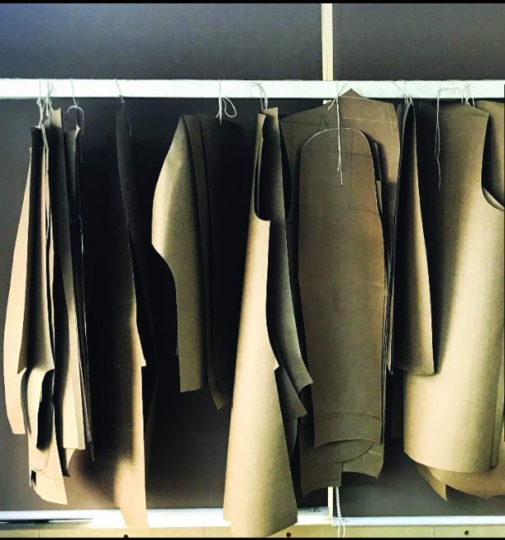

**Here we list down a few of the benefits of a handcrafted shirt which you just can’t ignore:**

1. **Offers you a Better quality of Fabrics:**Because handcrafted is always a better choice. When we talk about the quality, Handcrafted Shirts is the clear answer. With Abkasa’s premium range of Shirts, you will experience the magic of every single thread used in making the Shirt. The threads and material used by Abkasa is something similar to a dandelion.

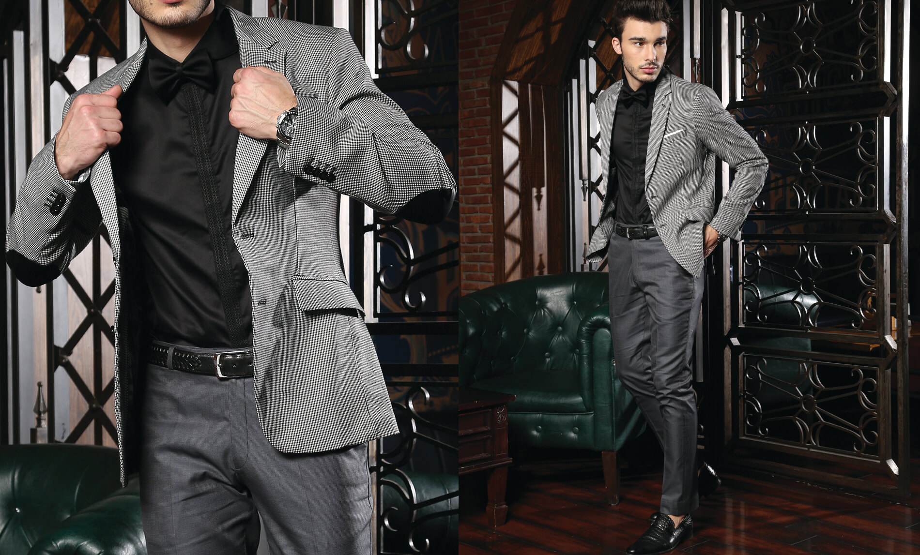

1. **Comes with a long life with durable threads:**Handcrafted Shirts surely becomes your best friend with an immortal friendship. Every Shirt by Abkasa comes with long life because of the quality of threads, fabrics and obviously our handmade efforts. Spending a few bucks more on a better brand and product always results in fruitful and long-lasting benefits.



1. **You can customize your shirt according to your body type:**Handmade! Yes, it’s more customizable. You can get a better fitting according to your body type when you go for a Handcrafted shirt. Because we believe that a perfect shirt is something which fits the best on your body type and size.

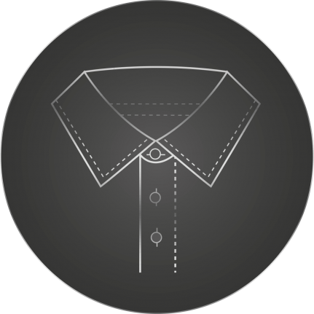

1. **Exclusive style and designs to give you a fresh look:**When we call it premium, we mean it. Every shirt by Abkasa comes with a guarantee of turning end number of heads on you. With our exceptionally stylish and trending designs, we always focus on selling a product worth spending for the sake of style and comfort.

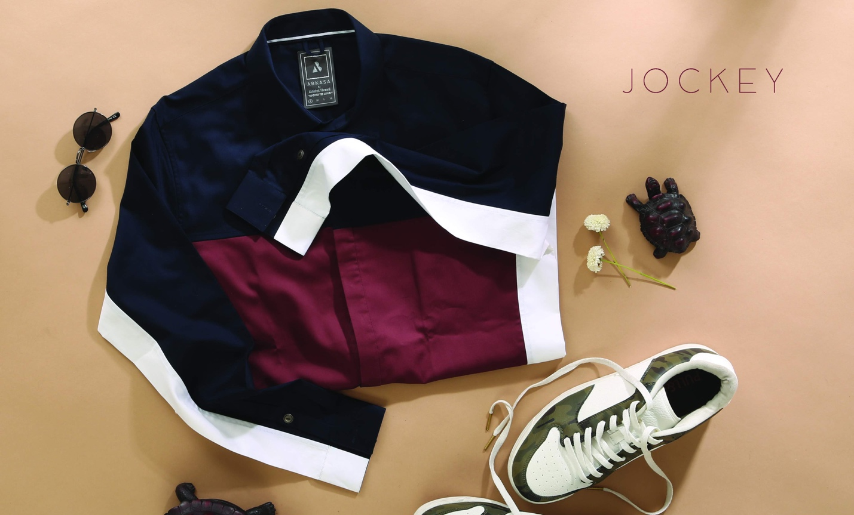

We at Abkasa knows how to play with those threads to sell a product you will love to flaunt. Our outlandish summer collection consists of a variety of Designer Handcrafted Shirts to give an appealing touch to your personality. Every single shirt designed by Abkasa is unique and something which will catch all the eyes on you. Life is too short to wear boring thread, with Abkasa live the trend.